https://www.microsoft.com/dynamics/crm/content/images/Help-Expand-Section-Microsoft-CRM.pngStep 1: Review installation prerequisites

https://www.microsoft.com/dynamics/crm/content/images/Help-Chapter-Open-Microsoft-CRM.pngSign in as a Local Administrator

* To install Dynamics CRM for Outlook, you must be able to sign in to your computer as a user with Local Administrator privileges.

In smaller companies, Dynamics CRM for Outlook is often installed manually, on a computer-by-computer basis. Administrators or individual users who have Local Administrator privileges and who possess a general familiarity with installing software can do these installations.

https://www.microsoft.com/dynamics/crm/content/images/Help-Chapter-Open-Microsoft-CRM.pngInstall updates

* Before you install Dynamics CRM for Outlook, make sure you have all the latest Microsoft Office updates, including all security updates from Microsoft Update
* To install Dynamics CRM 2015 for Outlook, you must have the appropriate security permissions.

https://www.microsoft.com/dynamics/crm/content/images/Help-Expand-Section-Microsoft-CRM.pngStep 2: Download the software

Before you or your users install Dynamics CRM 2015 for Outlook, please note the following:

* Make sure you have completed your desired CRM customizations. If your users will use Dynamics CRM 2015 for Outlook in offline mode, for best performance, enable only the minimum required record types (entities) and views for offline use. For more information, see
* Group Policy Folder Redirection with offline files is not supported in Dynamics CRM for Outlook. If your CRM data is stored with redirected offline files, users may be unable to use Dynamics CRM for Outlook. More information
* For synchronization to work correctly, we recommend that you turn on Cached Exchange Mode in Outlook. More information:

Downloads the Software

1 .Click on Get CRM for Outlook

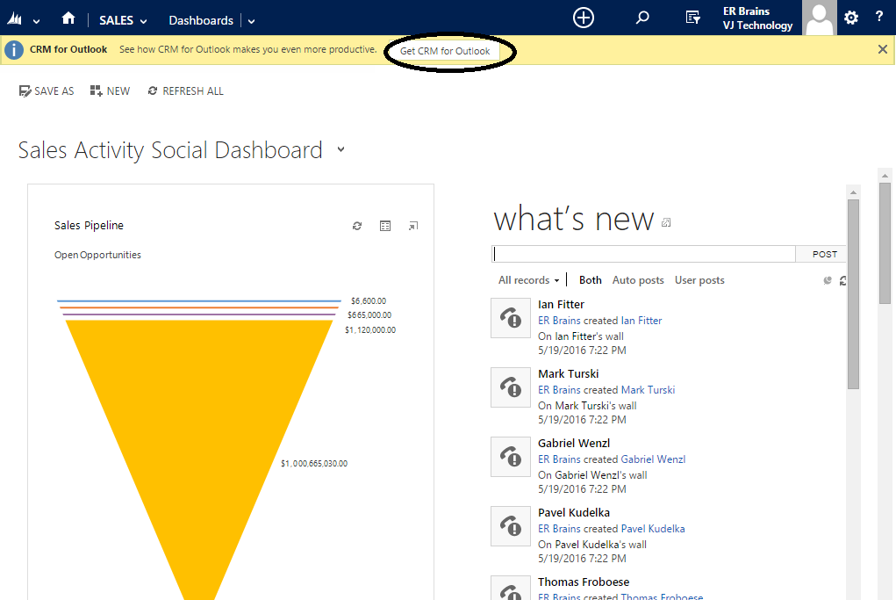

2. The software will start downloading and you’ll see the following dialog box:

Copy and Paste your organization’s URL to the Configure Section(2)

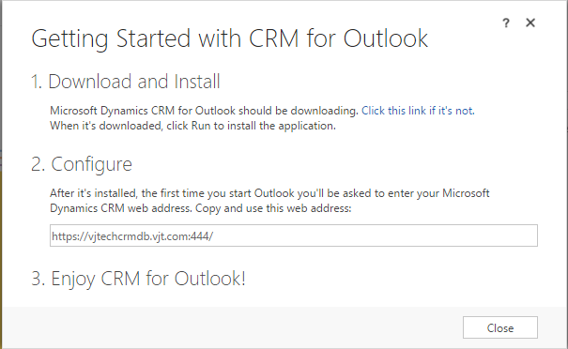

3. Click **Run**, when prompted, and browse the folder where you want to extract.

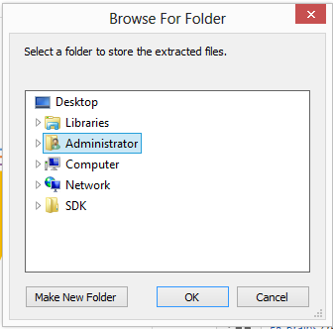

5. **License Agreement** page will be prompted, if you accept the license agreement, select **I accept the license agreement**, and then click **Next**

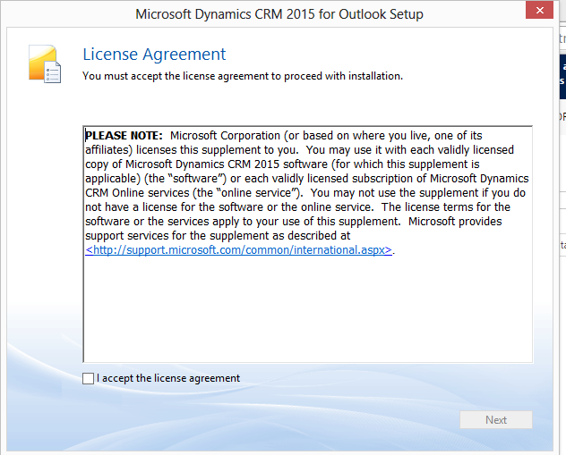

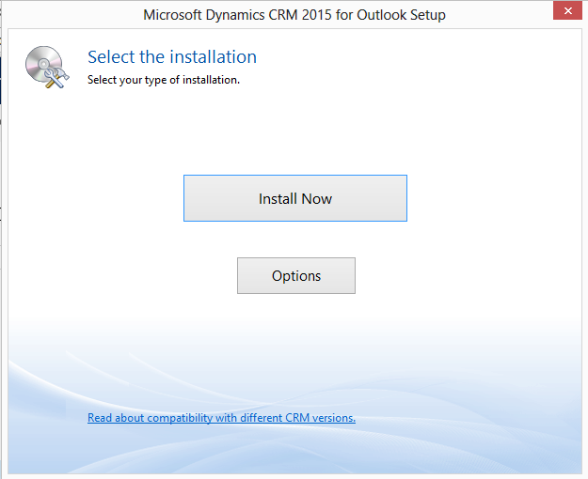

6. Do one of the following:

To install Dynamics CRM for Outlook without offline capability, click **Install Now**.

To install Dynamics CRM for Outlook with offline capability, click **Options**, select the **Offline Capability** check box on the **Customize Installation** page, and then click **Install Now**. If you don’t install offline capability during installation, you can add it later by choosing **Go Offline** in Dynamics CRM for Outlook.

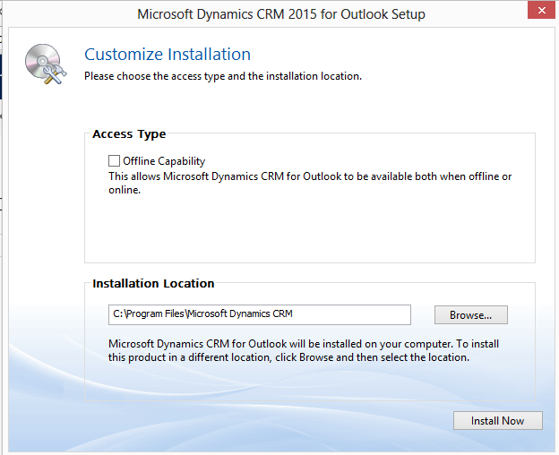

7. Click on Install Now

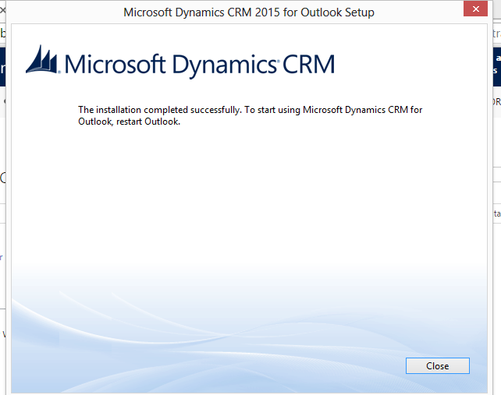

8. Restart the Outlook

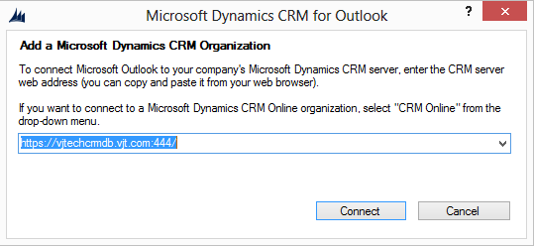

9. Enter the Server URL Which You Copied during second step, Click on Connect

10. Enter the Credentials, click Ok

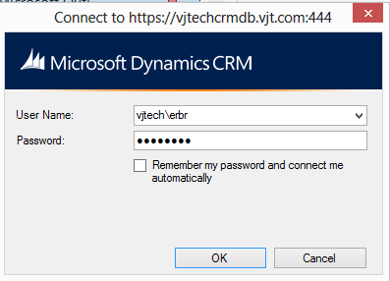

11. Select the organization

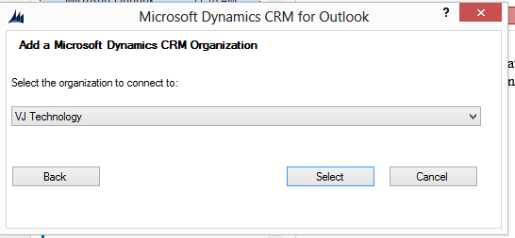

12. Integration Process begin 